**KEDELAI INOKULASI DAN KONTROL**

|  |  |  |  |
| --- | --- | --- | --- |
|  |  |  |  |
| 1. UBASK16 | 1. UBASK13 | 1. UBASK14 | 1. UBASK12 |
|  |  |  |  |
| 1. UBASK15 | 1. UBASK61 | 1. UBASK63 | 1. UBASK64 |
|  |  |  |  |
| 1. UBASK62 | 1. UBASK65 | 1. UBASK31 | 1. UBASK36 |
|  |  |  |  |
| 1. UBASK34 | 1. UBASK32 | 1. UBASK35 | 1. UBASK41 |
|  |  |  |  |
| 1. UBASK46 | 1. UBASK43 | 1. UBASK42 | 1. UBASK45 |
|  |  |  |  |
| 1. UBASK21 | 1. UBASK26 | 1. UBASK23 | 1. UBASK24 |
|  |  |  |  |
| 1. UBASK25 | 1. UBASK51 | 1. UBASK56 | 1. UBASK53 |
|  |  |  |  |
| 1. UBASK54 | 1. UBASK52 | 1. AJM | 1. AGP |
|  |  |  |  |
| 1. GBG | 1. TGM | 1. UB1 | 1. UB2 |

**KEDELAI TANPA POLYBAG**

|  |  |  |  |
| --- | --- | --- | --- |
|  |  |  |  |
| 1. UBASK16 | 1. UBASK13 | 1. UBASK14 | 1. UBASK12 |
|  |  |  |  |
| 1. UBASK15 | 1. UBASK61 | 1. UBASK63 | 1. UBASK64 |
|  |  |  |  |
| 1. UBASK62 | 1. UBASK65 | 1. UBASK31 | 1. UBASK36 |
|  |  |  |  |
| 1. UBASK34 | 1. UBASK32 | 1. UBASK35 | 1. UBASK41 |
|  |  |  |  |
| 1. UBASK46 | 1. UBASK43 | 1. UBASK42 | 1. UBASK45 |
|  |  |  |  |
| 1. UBASK21 | 1. UBASK26 | 1. UBASK23 | 1. UBASK24 |
|  |  |  |  |
| 1. UBASK25 | 1. UBASK51 | 1. UBASK56 | 1. UBASK53 |
|  |  |  |  |
| 1. UBASK54 | 1. UBASK52 | 1. AJM | 1. AGP |
|  |  |  |  |
| 1. GBG | 1. TGM | 1. UB1 | 1. UB2 |

**KEDELAI DENGAN POLYBAG**

|  |  |  |  |
| --- | --- | --- | --- |
|  |  |  |  |
| 1. UBASK16 | 1. UBASK13 | 1. UBASK14 | 1. UBASK12 |
|  |  |  |  |
| 1. UBASK15 | 1. UBASK61 | 1. UBASK63 | 1. UBASK64 |
|  |  |  |  |
| 1. UBASK62 | 1. UBASK65 | 1. UBASK31 | 1. UBASK36 |
|  |  |  |  |
| 1. UBASK34 | 1. UBASK32 | 1. UBASK35 | 1. UBASK41 |
|  |  |  |  |
| 1. UBASK46 | 1. UBASK43 | 1. UBASK42 | 1. UBASK45 |
|  |  |  |  |
| 1. UBASK21 | 1. UBASK26 | 1. UBASK23 | 1. UBASK24 |
|  |  |  |  |
| 1. UBASK25 | 1. UBASK51 | 1. UBASK56 | 1. UBASK53 |
|  |  |  |  |
| 1. UBASK54 | 1. UBASK52 | 1. AJM | 1. AGP |
|  |  |  |  |
| 1. GBG | 1. TGM | 1. UB1 | 1. UB2 |

**KONTROL**

|  |  |  |  |
| --- | --- | --- | --- |
|  |  |  |  |
| 1. UBASK16 | 1. UBASK13 | 1. UBASK14 | 1. UBASK12 |
|  |  |  |  |
| 1. UBASK15 | 1. UBASK61 | 1. UBASK63 | 1. UBASK64 |
|  |  |  |  |
| 1. UBASK62 | 1. UBASK65 | 1. UBASK31 | 1. UBASK36 |
|  |  |  |  |
| 1. UBASK34 | 1. UBASK32 | 1. UBASK35 | 1. UBASK41 |
|  |  |  |  |
| 1. UBASK46 | 1. UBASK43 | 1. UBASK42 | 1. UBASK45 |
|  |  |  |  |
| 1. UBASK21 | 1. UBASK26 | 1. UBASK23 | 1. UBASK24 |
|  |  |  |  |
| 1. UBASK25 | 1. UBASK51 | 1. UBASK56 | 1. UBASK53 |
|  |  |  |  |
| 1. UBASK54 | 1. UBASK52 | 1. AJM | 1. AGP |
|  |  |  |  |
| 1. GBG | 1. TGM | 1. UB1 | 1. UB2 |

**POLONG KEDELAI**

|  |  |  |  |
| --- | --- | --- | --- |
|  |  |  |  |
| 1. UBASK16 | 1. UBASK13 | 1. UBASK14 | 1. UBASK12 |
|  |  |  |  |
| 1. UBASK15 | 1. UBASK61 | 1. UBASK63 | 1. UBASK64 |
|  |  |  |  |
| 1. UBASK62 | 1. UBASK65 | 1. UBASK31 | 1. UBASK36 |
|  |  |  |  |
| 1. UBASK34 | 1. UBASK32 | 1. UBASK35 | 1. UBASK41 |
|  |  |  |  |
| 1. UBASK46 | 1. UBASK43 | 1. UBASK42 | 1. UBASK45 |
|  |  |  |  |
| 1. UBASK21 | 1. UBASK26 | 1. UBASK23 | 1. UBASK24 |
|  |  |  |  |
| 1. UBASK25 | 1. UBASK51 | 1. UBASK56 | 1. UBASK53 |
|  |  |  |  |
| 1. UBASK54 | 1. UBASK52 | 1. AJM | 1. AGP |
|  |  |  |  |
| 1. GBG | 1. TGM | 1. UB1 | 1. UB2 |

**BIJI KEDELAI**

|  |  |  |  |
| --- | --- | --- | --- |
|  |  |  |  |
| 1. UBASK16 | 1. UBASK13 | 1. UBASK14 | 1. UBASK12 |
|  |  |  |  |
| 1. UBASK15 | 1. UBASK61 | 1. UBASK63 | 1. UBASK64 |
|  |  |  |  |
| 1. UBASK62 | 1. UBASK65 | 1. UBASK31 | 1. UBASK36 |
|  |  |  |  |
| 1. UBASK34 | 1. UBASK32 | 1. UBASK35 | 1. UBASK41 |
|  |  |  |  |
| 1. UBASK46 | 1. UBASK43 | 1. UBASK42 | 1. UBASK45 |
|  |  |  |  |
| 1. UBASK21 | 1. UBASK26 | 1. UBASK23 | 1. UBASK24 |
|  |  |  |  |
| 1. UBASK25 | 1. UBASK51 | 1. UBASK56 | 1. UBASK53 |
|  |  |  |  |
| 1. UBASK54 | 1. UBASK52 | 1. AJM | 1. AGP |
|  |  |  |  |
| 1. GBG | 1. TGM | 1. UB1 | 1. UB2 |

**BENTUK DAUN**

|  |  |  |  |
| --- | --- | --- | --- |
|  |  |  |  |
| 1. UBASK16 | 1. UBASK13 | 1. UBASK14 | 1. UBASK12 |
|  |  |  |  |
| 1. UBASK15 | 1. UBASK61 | 1. UBASK63 | 1. UBASK64 |
|  |  |  |  |
| 1. UBASK62 | 1. UBASK65 | 1. UBASK31 | 1. UBASK36 |
|  |  |  |  |
| 1. UBASK34 | 1. UBASK32 | 1. UBASK35 | 1. UBASK41 |
|  |  |  |  |
| 1. UBASK46 | 1. UBASK43 | 1. UBASK42 | 1. UBASK45 |
|  |  |  |  |
| 1. UBASK21 | 1. UBASK26 | 1. UBASK23 | 1. UBASK24 |
|  |  |  |  |
| 1. UBASK25 | 1. UBASK51 | 1. UBASK56 | 1. UBASK53 |
|  |  |  |  |
| 1. UBASK54 | 1. UBASK52 | 1. AJM | 1. AGP |
|  |  |  |  |
| 1. GBG | 1. TGM | 1. UB1 | 1. UB2 |

**KERAPATAN STOMATA DAUN**

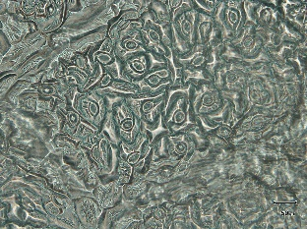 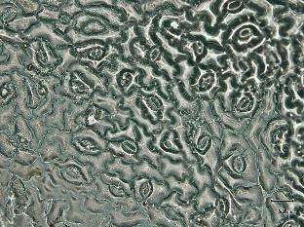

b

a

Kerapatan stomata pada (a) UBASK26 dan (b) UBASK64

|  |  |  |  |
| --- | --- | --- | --- |
|  |  |  |  |
| 1. UBASK16 | 1. UBASK13 | 1. UBASK14 | 1. UBASK12 |
|  |  |  |  |
| 1. UBASK15 | 1. UBASK61 | 1. UBASK63 | 1. UBASK64 |
|  |  |  |  |
| 1. UBASK62 | 1. UBASK65 | 1. UBASK31 | 1. UBASK36 |
|  |  |  |  |
| 1. UBASK34 | 1. UBASK32 | 1. UBASK35 | 1. UBASK41 |
|  |  |  |  |
| 1. UBASK46 | 1. UBASK43 | 1. UBASK42 | 1. UBASK45 |
|  |  |  |  |
| 1. UBASK21 | 1. UBASK26 | 1. UBASK23 | 1. UBASK24 |
|  |  |  |  |
| 1. UBASK25 | 1. UBASK51 | 1. UBASK56 | 1. UBASK53 |
|  |  |  |  |
| 1. UBASK54 | 1. UBASK52 | 1. AJM | 1. AGP |
|  |  |  |  |
| 1. GBG | 1. TGM | 1. UB1 | 1. UB2 |

**KERAPATAN TRIKOMA DAUN**

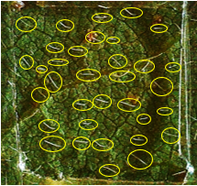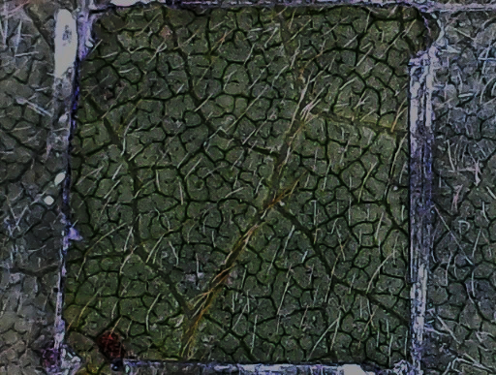

a

b

Kerapatan trikoma pada (a) UBASK53 dan (b) UBASK14

|  |  |  |  |
| --- | --- | --- | --- |
|  |  |  |  |
| 1. UBASK16 | 1. UBASK13 | 1. UBASK14 | 1. UBASK12 |
|  |  |  |  |
| 1. UBASK15 | 1. UBASK61 | 1. UBASK63 | 1. UBASK64 |
|  |  |  |  |
| 1. UBASK62 | 1. UBASK65 | 1. UBASK31 | 1. UBASK36 |
|  |  |  |  |
| 1. UBASK34 | 1. UBASK32 | 1. UBASK35 | 1. UBASK41 |
|  |  |  |  |
| 1. UBASK46 | 1. UBASK43 | 1. UBASK42 | 1. UBASK45 |
|  |  |  |  |
| 1. UBASK21 | 1. UBASK26 | 1. UBASK23 | 1. UBASK24 |
|  |  |  |  |
| 1. UBASK25 | 1. UBASK51 | 1. UBASK56 | 1. UBASK53 |
|  |  |  |  |
| 1. UBASK54 | 1. UBASK52 | 1. AJM | 1. AGP |
|  |  |  |  |
| 1. GBG | 1. TGM | 1. UB1 | 1. UB2 |

**TEBAL DAUN DAN TEBAL EPIDERMIS**

b

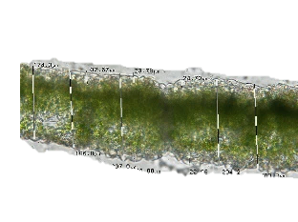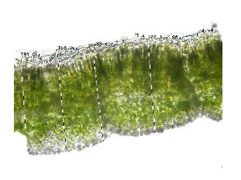

a

Tebal daun

Tebal epidermis

Tebal daun

Tebal epidermis

Tebal epidermis daun pada (a) UBASK41 dan (b) UBASK34

|  |  |  |  |
| --- | --- | --- | --- |
|  |  |  |  |
| 1. UBASK16 | 1. UBASK13 | 1. UBASK14 | 1. UBASK12 |
|  |  |  |  |
| 1. UBASK15 | 1. UBASK61 | 1. UBASK63 | 1. UBASK64 |
|  |  |  |  |
| 1. UBASK62 | 1. UBASK65 | 1. UBASK31 | 1. UBASK36 |
|  |  |  |  |
| 1. UBASK34 | 1. UBASK32 | 1. UBASK35 | 1. UBASK41 |
|  |  |  |  |
| 1. UBASK46 | 1. UBASK43 | 1. UBASK42 | 1. UBASK45 |
|  |  |  |  |
| 1. UBASK21 | 1. UBASK26 | 1. UBASK23 | 1. UBASK24 |
|  |  |  |  |
| 1. UBASK25 | 1. UBASK51 | 1. UBASK56 | 1. UBASK53 |
|  |  |  |  |
| 1. UBASK54 | 1. UBASK52 | 1. AJM | 1. AGP |
|  |  |  |  |
| 1. GBG | 1. TGM | 1. UB1 | 1. UB2 |

**PUSTUL KARAT**

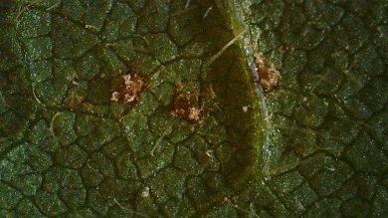

Pustul pada UBASK63

|  |  |  |
| --- | --- | --- |
| Description: C:\Users\User\Pictures\Camera Roll\1\WIN_20230510_21_41_41_Pro.jpg | Description: C:\Users\User\Pictures\Camera Roll\2\WIN_20230510_21_46_14_Pro.jpg | Description: C:\Users\User\Pictures\Camera Roll\3\WIN_20230509_00_14_08_Pro.jpg |
| 1. UBASK16 | 2. UBASK13 | 3. UBASK14 |
| Description: C:\Users\User\Pictures\Camera Roll\4\WIN_20230509_00_09_53_Pro.jpg | Description: C:\Users\User\Pictures\Camera Roll\5\WIN_20230509_00_05_05_Pro.jpg | Description: C:\Users\User\Pictures\Camera Roll\6\WIN_20230511_02_18_52_Pro.jpg |
| 4. UBASK12 | 5. UBASK15 | 6. UBASK61 |
| Description: C:\Users\User\Pictures\Camera Roll\7\WIN_20230511_04_52_02_Pro.jpg | Description: C:\Users\User\Pictures\Camera Roll\8\WIN_20230511_05_14_00_Pro.jpg | Description: C:\Users\User\Pictures\Camera Roll\9\WIN_20230511_05_15_30_Pro.jpg |
| 7. UBASK63 | 8. UBASK64 | 9. UBASK62 |
| Description: C:\Users\User\Pictures\Camera Roll\10\WIN_20230511_05_19_45_Pro.jpg | Description: C:\Users\User\Pictures\Camera Roll\11\WIN_20230508_23_18_59_Pro.jpg | Description: C:\Users\User\Pictures\Camera Roll\12\WIN_20230508_23_34_43_Pro.jpg |
| 10. UBASK65 | 11. UBASK31 | 12. UBASK36 |
| Description: C:\Users\User\Pictures\Camera Roll\13\WIN_20230508_23_45_54_Pro.jpg | Description: C:\Users\User\Pictures\Camera Roll\14\WIN_20230508_23_50_37_Pro.jpg | Description: C:\Users\User\Pictures\Camera Roll\15\WIN_20230508_23_56_59_Pro.jpg |
| 13. UBASK34 | 14. UBASK32 | 15. UBASK35 |
| Description: C:\Users\User\Pictures\Camera Roll\16\WIN_20230511_04_48_53_Pro.jpg | Description: C:\Users\User\Pictures\Camera Roll\17\WIN_20230511_04_44_19_Pro.jpg | Description: C:\Users\User\Pictures\Camera Roll\18\WIN_20230511_02_27_39_Pro.jpg |
| 16. UBASK41 | 17. UBASK46 | 18. UBASK43 |
| Description: C:\Users\User\Pictures\Camera Roll\19\WIN_20230511_02_34_49_Pro.jpg | Description: C:\Users\User\Pictures\Camera Roll\20\WIN_20230511_04_38_57_Pro.jpg | Description: C:\Users\User\Pictures\Camera Roll\21\WIN_20230511_04_37_16_Pro.jpg |
| 19. UBASK42 | 20. UBASK45 | 21. UBASK21 |
| Description: C:\Users\User\Pictures\Camera Roll\22\WIN_20230511_04_32_56_Pro.jpg | Description: C:\Users\User\Pictures\Camera Roll\23\WIN_20230511_04_28_58_Pro.jpg | Description: C:\Users\User\Pictures\Camera Roll\24\WIN_20230511_04_24_44_Pro.jpg |
| 22. UBASK26 | 23. UBASK23 | 24. UBASK24 |
| Description: C:\Users\User\Pictures\Camera Roll\25\WIN_20230510_06_07_00_Pro.jpg | Description: C:\Users\User\Pictures\Camera Roll\26\WIN_20230511_04_19_50_Pro.jpg | Description: C:\Users\User\Pictures\Camera Roll\27\WIN_20230511_04_14_28_Pro.jpg |
| 25. UBASK25 | 26. UBASK51 | 27. UBASK56 |
| Description: C:\Users\User\Pictures\Camera Roll\28\WIN_20230511_03_57_12_Pro.jpg | Description: C:\Users\User\Pictures\Camera Roll\29\WIN_20230511_03_48_56_Pro.jpg | Description: C:\Users\User\Pictures\Camera Roll\30\WIN_20230511_03_42_22_Pro.jpg |
| 28. UBASK53 | 29. UBASK54 | 30. UBASK52 |
| Description: C:\Users\User\Pictures\Camera Roll\31\WIN_20230511_03_37_29_Pro.jpg | Description: C:\Users\User\Pictures\Camera Roll\32\WIN_20230511_03_33_35_Pro.jpg | Description: C:\Users\User\Pictures\Camera Roll\33\WIN_20230511_02_56_54_Pro.jpg |
| 31. AJM | 32. AGP | 33. GBG |
| Description: C:\Users\User\Pictures\Camera Roll\34\WIN_20230511_02_50_05_Pro.jpg | Description: C:\Users\User\Pictures\Camera Roll\35\WIN_20230511_02_43_06_Pro.jpg | Description: C:\Users\User\Pictures\Camera Roll\36\WIN_20230511_02_37_31_Pro.jpg |
| 34. TGM | 35. UB1 | 36. UB2 |